REQUIREMENTS DOCUMENT
PROJECT NAME: |  |  | Type
RD_REORDERS of Legacy Orders (FE) |  |  | New Feature
STAKEHOLDER |  | US UI/UX:
Dan Burns |  | Emme Ferguson
BA AUTHOR:
Rolando Arduo Jr.
PROJECT MANAGER:
Ma. Giselle Dionesio
DEVELOPMENT TEAM: (INCLUDING UI/UX)
SQA TEAM:
OTHER TEAMS:
PRIORITY: |  | BRAND:
High |  | LEGACY BRANDS

PROJECT INITIAL REQUIREMENTS FROM STAKEHOLDERS
Goal: the end user needs to be able reorder legacy items on the Customizer.
this is a prerequiste to getting the End users and sales rep out of Qstrike.
the front end requirement to accomplish this goal are being handle by the ticket https://prolook.monday.com/boards/4880298520/pulses/11094846710
additional information. We intend to make this work only using price items we do not want to create block or styles for to accomplish this request.
To make that work we are requesting some change to the price items.
1. we would like to add a check box on the price item that will indicate if this price item is going to be used as a price item for a legacy item.
2. if that check box is marked as true, several change will happen on the price item.
- a new roster group field will become available. on this filed you will select from our existing list of Roster groups to designate what roster options are available for this legacy item.
- Quickstrike Item ID fields will become available. if at all possible we would like to copy what format and fields that are present in Qstrike Item ID modal into the Price item.
  - This would include the fields in the modal and the functionality. ( meaning if the price item has 3 brand item ID's and 3 size groups, this modal will have those fields and 3 open field for the Quickstrike Item ID)
- we would like to include a + button under the Quickstrike Item ID fields
  - if that button is hit another group of the quickstrike item id modals will become available. allow us to tie several legacy items to the same Price item to address legacy twill items
- The fabric selection should be grayed out. as fabric will not be selectable. but we will still have one pricing table available to set the prices for that reorded item.
as an additional thought we might be able to group all the reorder related information (Roster group and quickstrike Item IDs into there own Modal inside the Price item that might be cleaner).
Update: Legacy Reorder Deletion Flow:
Flow
- Factory requests deletion of a legacy reorder item
- Request is reviewed by Dan Mullins and Devri Christensen
- Item is deleted once confirmed it cannot be fulfilled
User Experience
- User receives an email explaining the deletion, using the note entered by Dan or Devri
- Deleted items appear grayed out on the Orders page with limited information:
  - Item picture
  - Item name
  - Org
  - Web Order #
  - “Deleted” status badge
- A “View Issue” button appears on hover (same placement as “Fix Issue”)
View Issue Behavior
- Opens the customizer to the Issues / Logs tab
- Displays the deletion note with timestamp
- No “Resolve and Submit” action (item is permanently deleted)
Access Points
- “View Issue” is accessible from:
  - Orders list
  - Order view
  - Item view
  - Directly from the email
Designs are attached to show how this appears within the Orders page. Thank you.

QX7 CHECKLIST
SECTION | YES/NO | NOTES
OTHER QX7 PAGES | YES | FINANCE ➡️ PRICE ITEMS
FE IMPLEMENTATION
SYSTEM PERFORMANCE

CUSTOMIZER CHECKLIST
SECTION | YES/NO | NOTES
CUSTOMIZER LANDING PAGE
SPORT PICKER
PRODUCT PICKER
PRODUCT PICKER MODALS
PRODUCT PICKER (LOADING TIME)
BUILDER
SHOPPING CART
SHOPPING CART FLYOUT
ADMIN PAGES
PDF
PDF SERVICE
CHECKOUT PAGE
QSTRIKE SYSTEM
SYSTEM PERFORMANCE

PRODUCTS CHECKLIST
SECTION | YES/NO | NOTES
STOCKS
HYBRID
SUBLIMATED
TWILL
REVERSIBLE
BAGS

PROJECT REQUIREMENTS

BUSINESS REQUIREMENTS
NAME | DESCRIPTION
FUNCTIONAL REQUIREMENTS
NAME | DESCRIPTION
Orders Page and Legacy Items  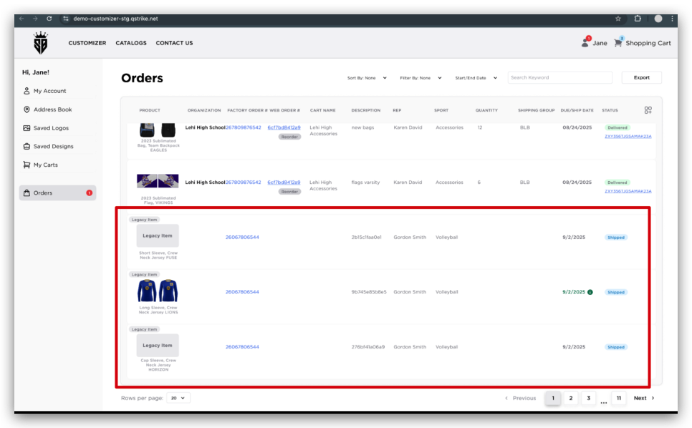 | - If a downloadable PDF exists, users can download it as normal  - If a PDF is not available, the option will simply not be available  - Orders page: showing how legacy items appear within the list  - Legacy items may contain varying amounts of available or missing data. If certain data is missing, the corresponding field simply will not appear in the UI  - In the column adder, "Invoice Number" is an optional column to turn on, which should help identify Legacy items. (Example: 25051151-0515 within the sample data)  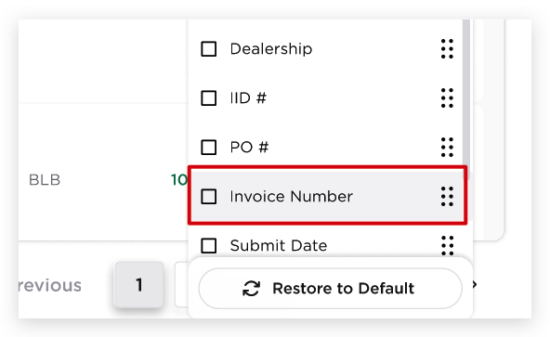
Legacy Thumbnail behavior  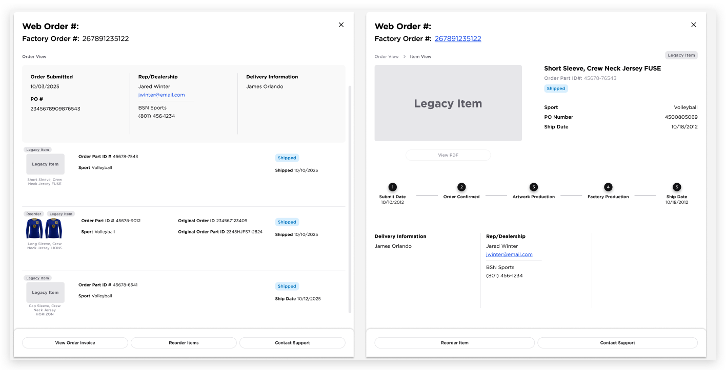 | - If a thumbnail exists, it will display normally with a “Legacy Item” badge in the top-left corner of the item row on the Orders page.  - If a thumbnail does not exist, the thumbnail area will be replaced with a “Legacy Item” placeholder so users still understand the item is from a legacy system. The badge will still appear for consistency  - Order drawer: Some fields are missing depending on available data; the layout should still appear as condensed and clean as possible  - Item view: Some information may be missing, and the View PDF button is disabled when a PDF is not available. The legacy badge and placeholder image clearly indicate the item’s status
Reorder Legacy Item  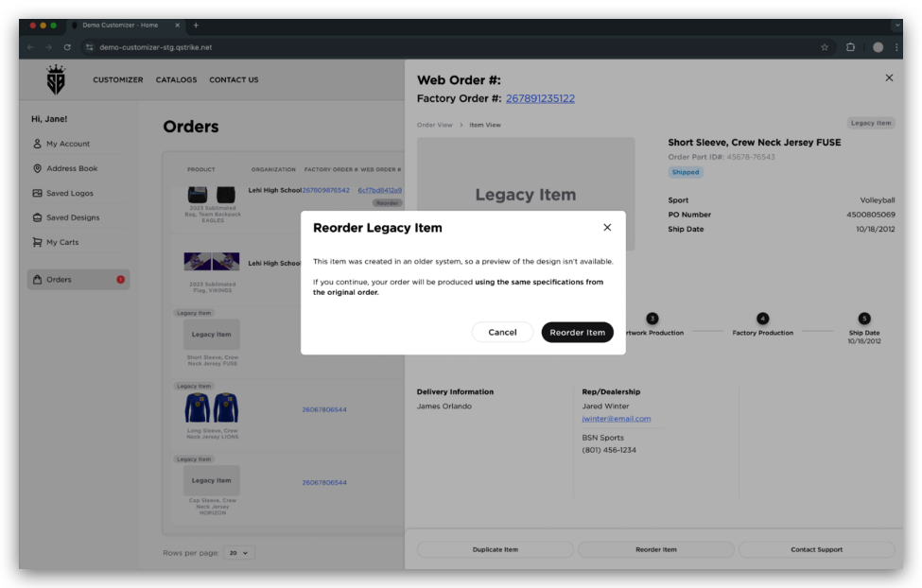 | - If the REORDER ITEM button is clicked for the Legacy item, a modal will pop up that contains:  - Header: Reorder Legacy Item  - Wording: “This item was created in an older system, so a preview of the design isn’t available.  If you continue, your order will be produced using the same specifications from the original order.”  - Cancel button  - Reorder Item button  - If the user selects “Reorder Item” on the modal, they can then proceed to add a roster (if needed) and add the item to their cart  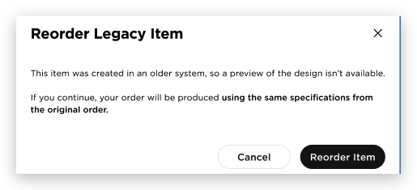
Legacy Reorder Deletion  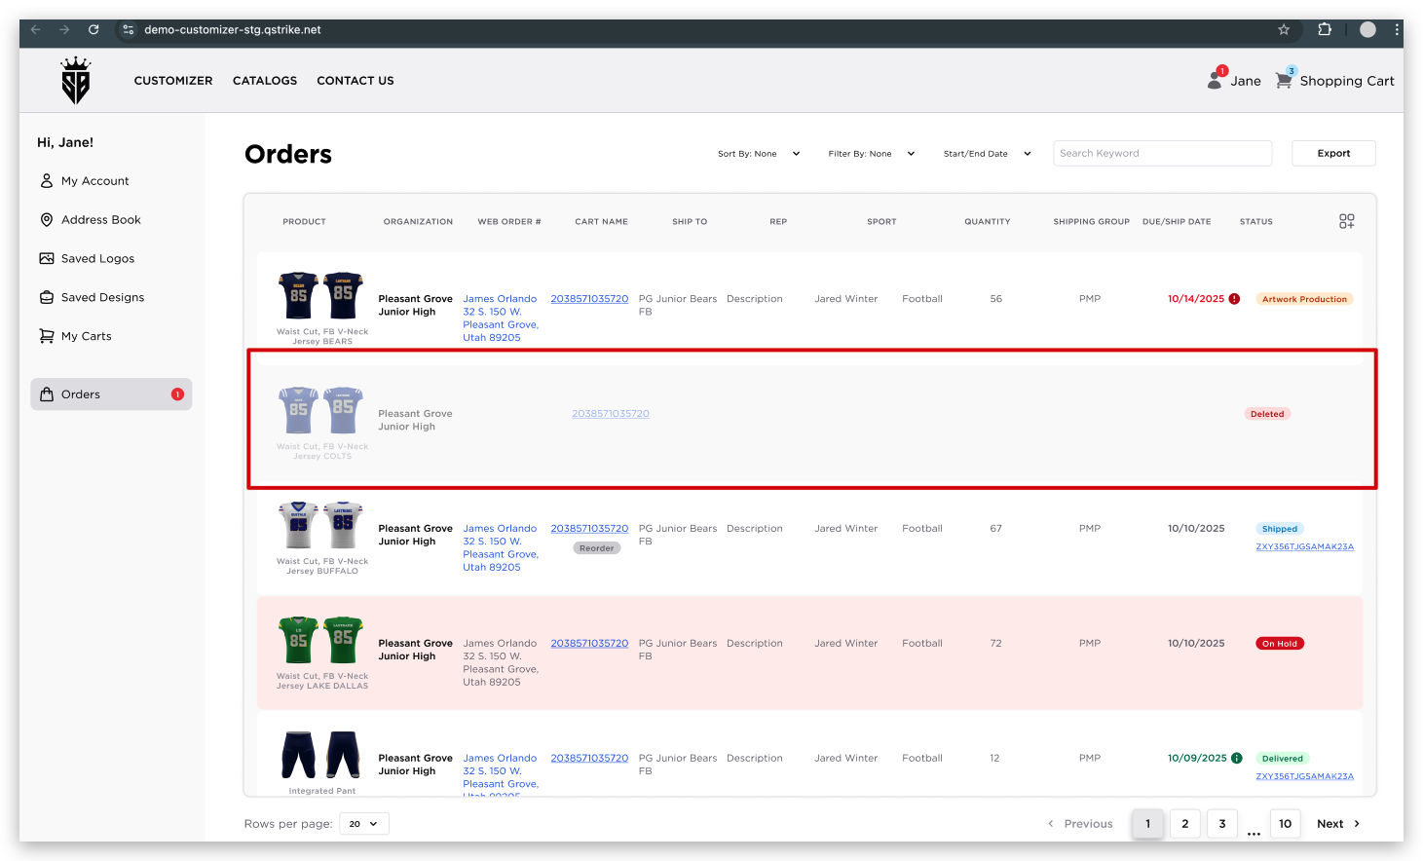  Note: If the picture is too small, please refer to the Figma link | - This will be handled using the existing rejection process and/or an Operational change that Mullins will be in charge of (We're thinking about training the team to email him and Devri about the deletion instead of using rejection. Either way, there is no change from current expectations/process)  - Request is reviewed by Dan Mullins and Devri Christensen (no additional work needed for this)  - Item is deleted once confirmed it cannot be fulfilled - this should happen in our existing factory system as it stands, but we may be pulling the Deletion reason from the factory system to provide the message for the customizer  - The user will notice the item is grayed out and has a deleted red badge  - In the index page, Web Order # is still clickable on a deleted item. You can still view your order drawer and item drawer  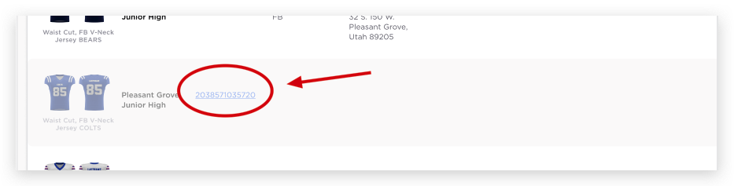  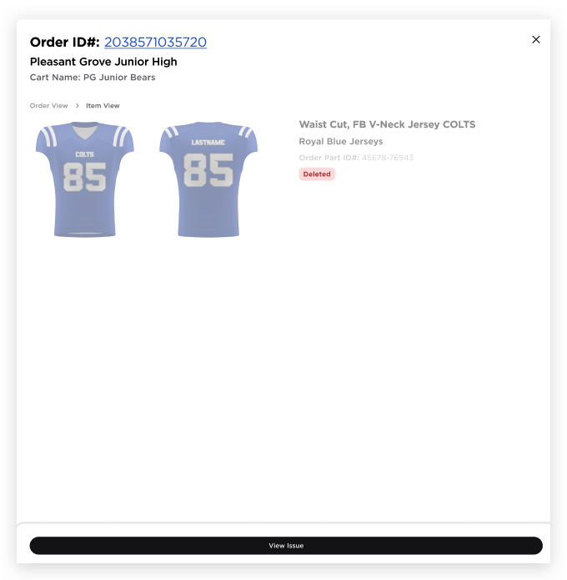  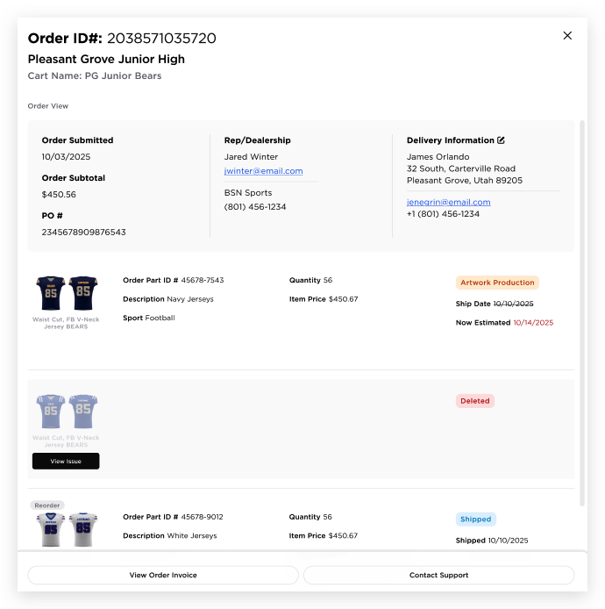  - The email below is triggered whenever Dan Mullins or Devri clicks "Delete" in the factory production site. The "View Issue" button within the email will direct users to the builder page, where they can see the reason for the deletion in the "Logs" (in the issues/logs tab). This is a very similar flow to the rejection email, where clicking "Fix Issue" takes users into the customizer on the issues tab. The only difference is that with this flow, users are taken to the Logs tab within Issues/Logs  - Displays the deletion note with a timestamp  - No “Resolve and Submit” action (item is permanently deleted)  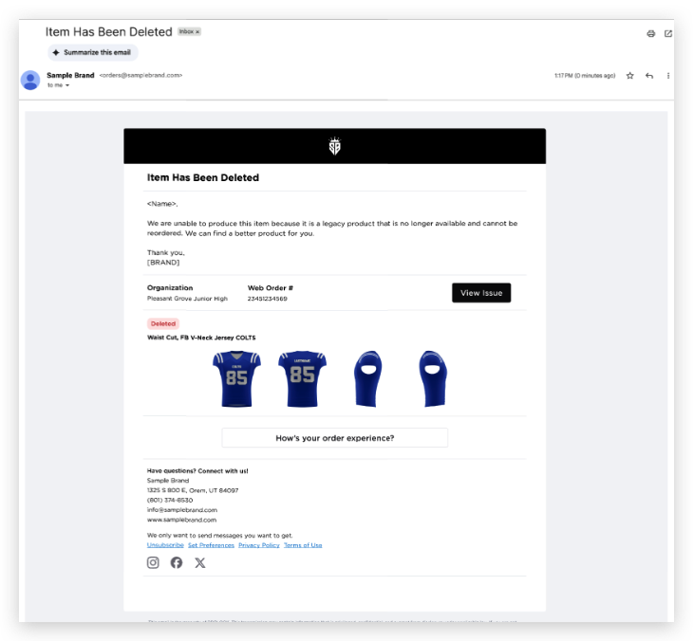  - Deleted items should restore the allotments for the associated part that was deleted
OUT OF SCOPE REQUIREMENTS
NAME | DESCRIPTION

REFERENCES
NAME | LOCATION
Final Design Figma Link | https://www.figma.com/design/ED5PAfAac5IPyMcy9uD3CU/Order-Tracking?node-id=6672-30903&t=RORtD5lWCtA50Ice-0
Monday ticket | https://prolook.monday.com/boards/4880298520/pulses/11094846710
Hand-off Video
Recording Session
Technical Specs

